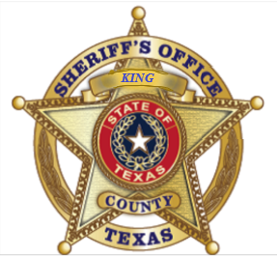

Brown Female Horse

On 12 December 2024 at 10 am James Gilmore called to report a horse on HWY 83 on the King/Cottle Co. Line.

The horse was captured and placed in a pen on the Gilmore property while efforts are made to contact the owner of said horse.

The horse shall remain on the Gilmore property until the owner claims the horse.

To claim the horse contact the King Co Sheriff’s Office at 806-596-4413.

Michael R. McWhirter

King County Sheriff